Hướng dẫn graphic.h và WBG

Cách hoạt động:

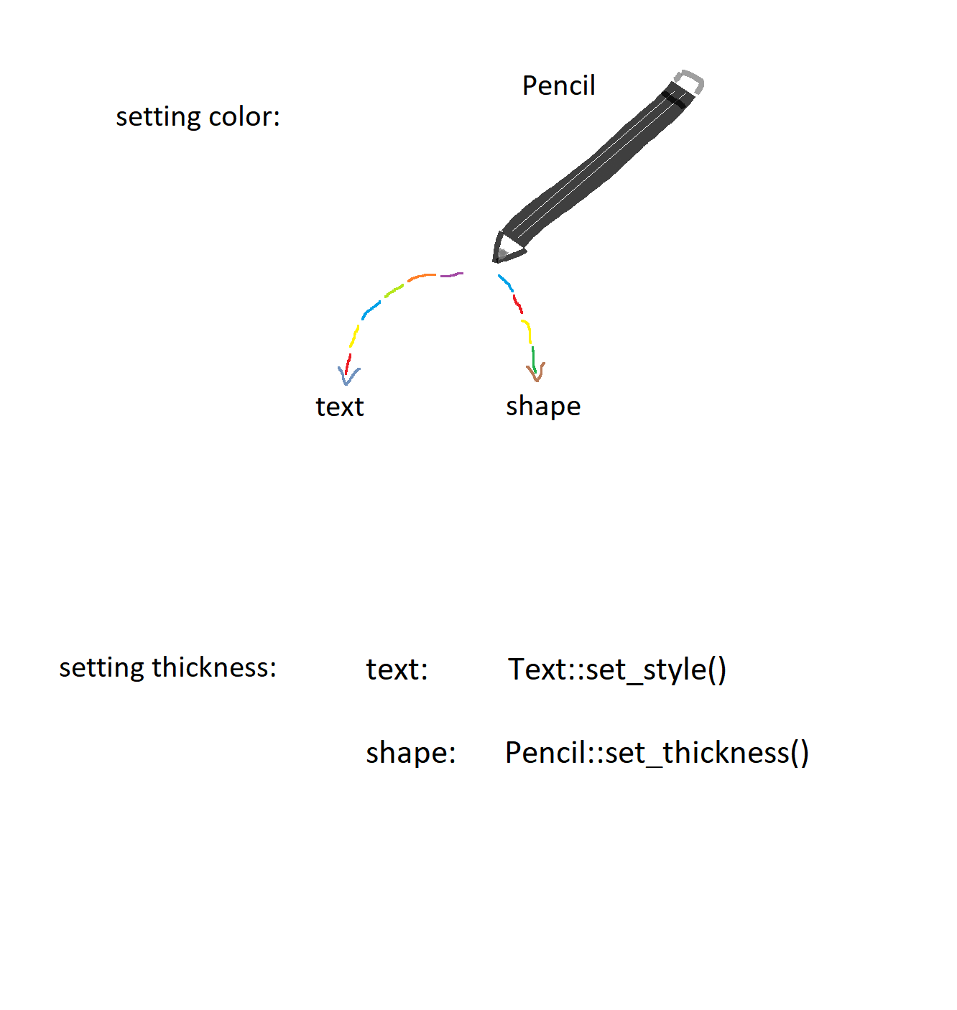

|  |  |
| --- | --- |
|  | #define BLACK 0  #define BLUE 1  #define GREEN 2  #define CYAN 3  #define RED 4  #define MAGENTA 5  #define BROWN 6  #define LIGHTGRAY 7  #define DARKGRAY 8  #define LIGHTBLUE 9  #define LIGHTGREEN 10  #define LIGHTCYAN 11  #define LIGHTRED 12  #define LIGHTMAGENTA 13  #define YELLOW 14  #define WHITE 15 |

color: